City of Bonita Springs
Legislative Priorities
2017
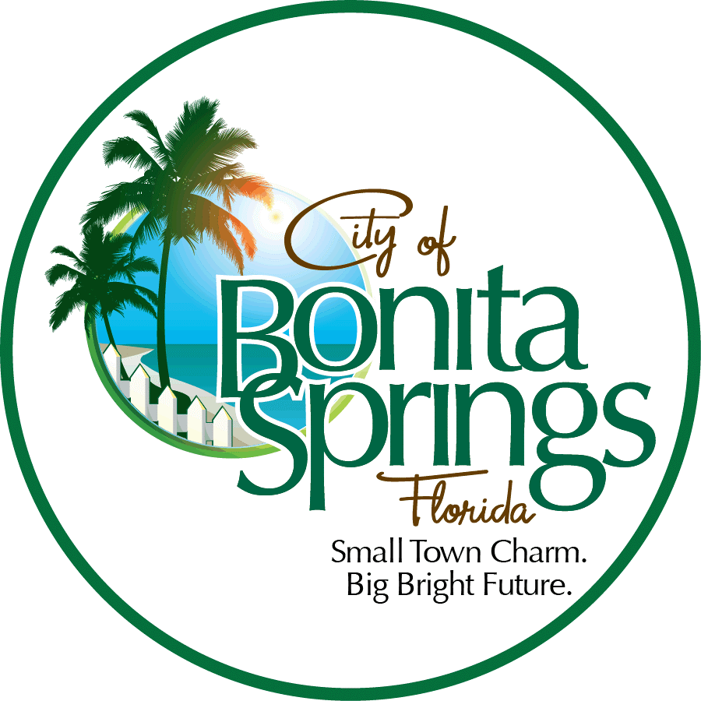

Lee County Delegation Meeting
January 19, 2017

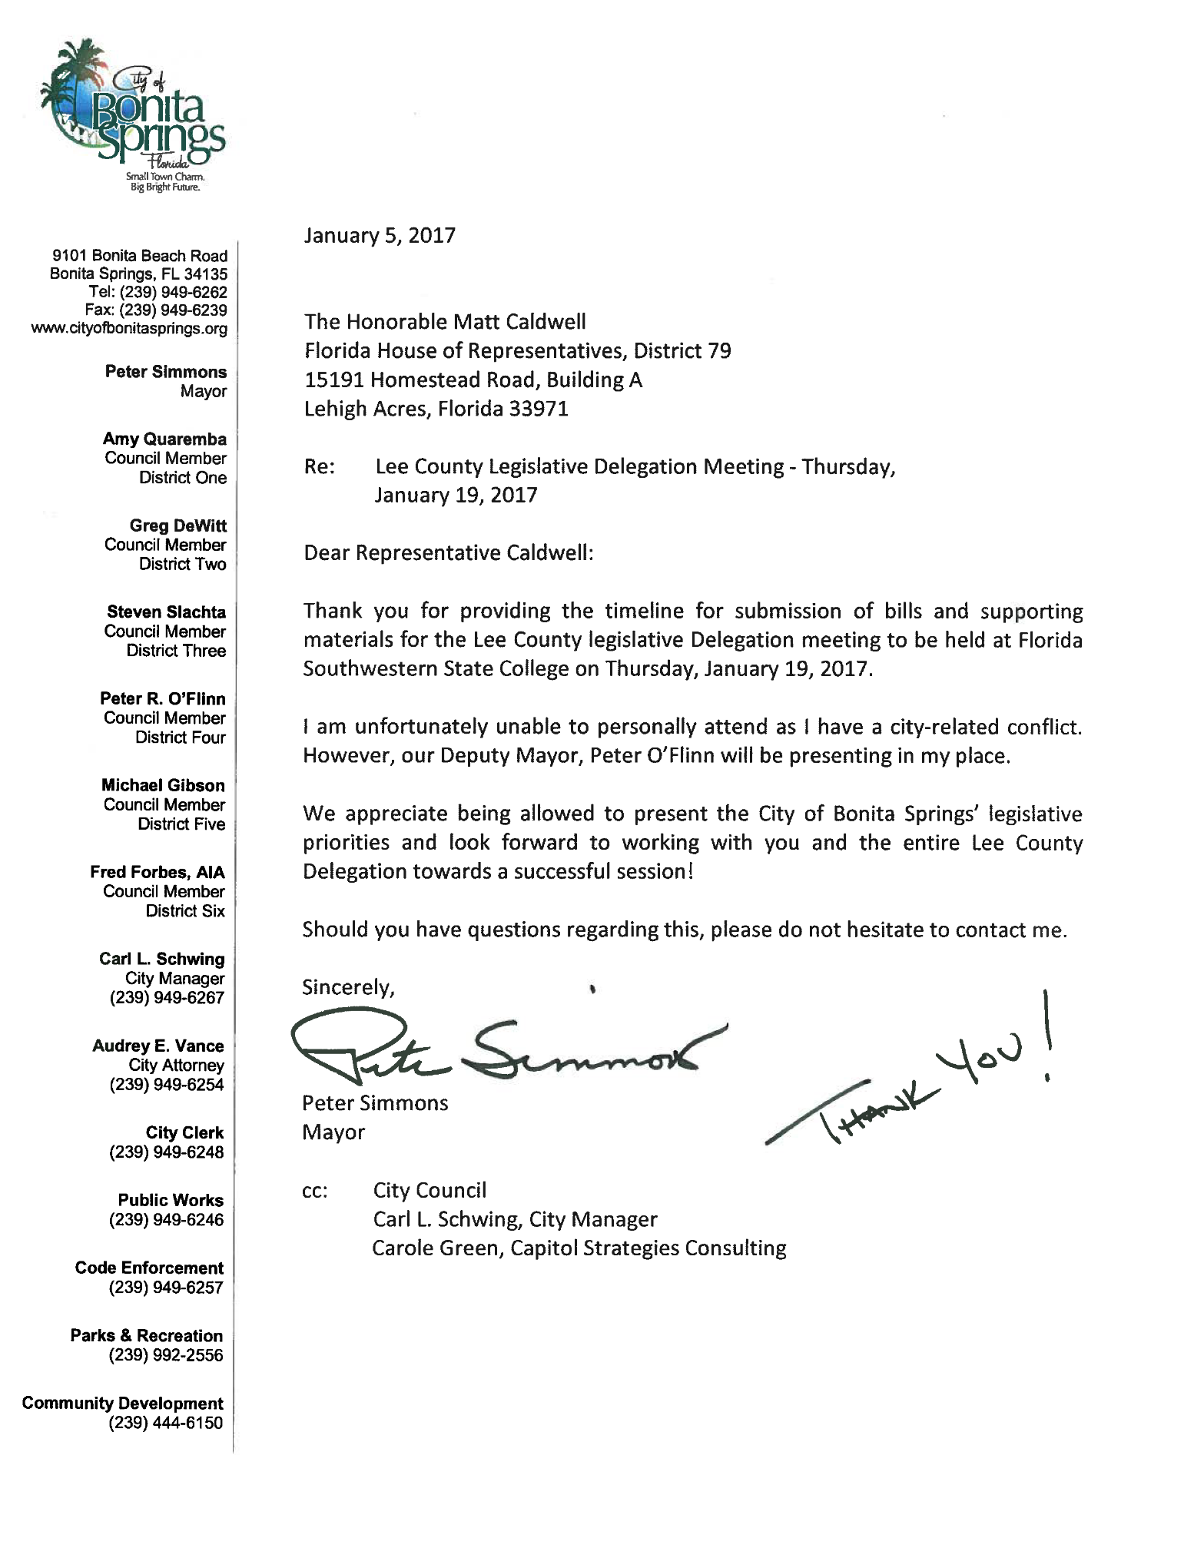

FUNDING REQUESTS:

WATER QUALITY: PINE LAKE PRESERVE PROJECT REQUEST: $1 Million (Local Match: $500,000)
The City of Bonita Springs believes that water quality is a critically important issue attached not only to safety, but also to the unique lifestyle and quality of life we all enjoy in Southwest Florida. The Imperial River, which runs directly through the city, has been determined to be impaired with an established TMDL for nitrogen pollution reduction in the Imperial River’s freshwater basin. While making strides to implement the state mandated TMDL reductions within our boundaries, much happens outside the city’s boundaries that impacts our ability to respond in a meaningful way. The City has already spent in excess of $7.4 Million to meet these state requirements.
This is clearly a regional issue. The Imperial River is a receiver from three different water sheds, increasing its importance in the region for financial assistance from partner agencies. The request for $1.0 million, with a match from the City of $500,000, would provide a significant boost in achieving the State’s TMDL nitrogen reduction quotas in the Imperial River’s freshwater basin.
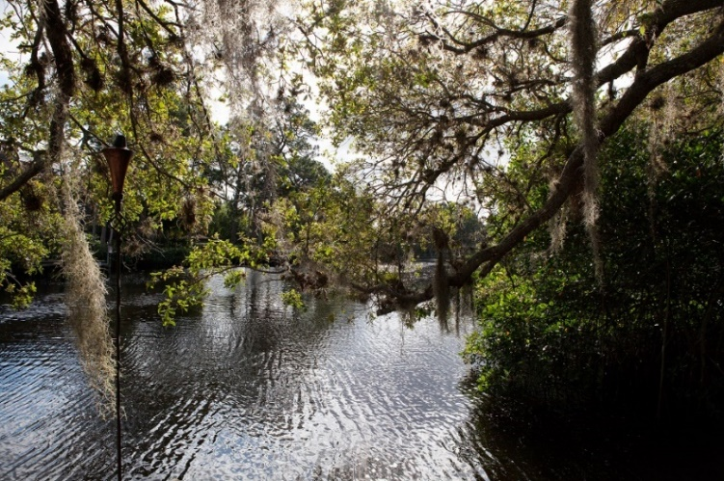
IMPERIAL
RIVER
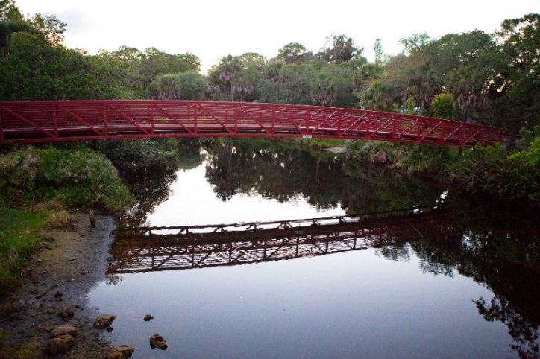

Pine Lake Preserve Hydrologic Restoration Project
City of Bonita Springs Public Works Department & Lee County Conservation 20/20 Program

Purpose:
The City of Bonita Springs and Lee County have entered into an agreement for the design, permitting, and construction of the Pine Lake Preserve hydrologic restoration project. The proposed hydrologic restoration project includes Pine Lake Preserve located within the City of Bonita Springs.

Background:
Pine Lake Preserve historically included the headwaters of the Imperial River with surface water sheet flowing from the north and east through the property to a series of small feeder creeks connecting to form the Imperial River. The construction of the Kehl Canal in the 1960’s combined with the construction of roadways, altered the sheet flow pattern mainly into canals and ditches. Additionally, unimproved roads and mine excavation areas within the property, created prior to the establishment of the preserve, further altered the sheet flow pattern and wetland hydro period within Pine Lake Preserve.
As mentioned previously, The City of Bonita Springs takes water quality issues very seriously. The Imperial River, which runs through the center of the City, has already been determined to be “impaired”. The TMDL reduction requirements imposed by the state are difficult to achieve, especially given the costs and that the pollutants come into the City from areas to the northeast of the city – where the City has no jurisdiction – yet it is the City’s obligation to improve it -- including the millions we have spent and are obligated to spend as documented in the City’s budget. The Imperial River is critical to the city’s history, beauty, and economic development through eco-tourism.
Extensive field investigations were conducted between late August 2015 and March 2016 to gather site specific information to design the project with the least amount of environmental impact to achieve the main project goals of restoring sheet flow and improving the water quality of storm water discharging into the Imperial River.
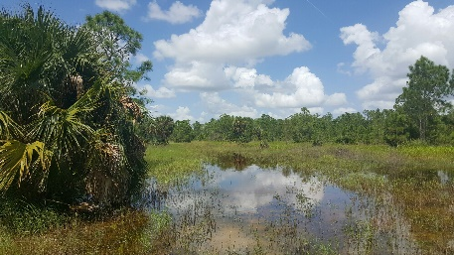
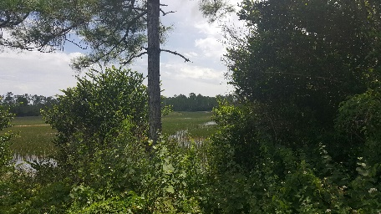

Proposed Benefits:
The proposed project will provide environmental benefits both within the preserve and within the Imperial River watershed through the following:
• restoring sheet flow through the preserve reducing the amount of storm water flowing through roadside ditches along East Terry Street, Kent Road, and Bonita Grande; and
• lowering existing vehicle trails within the preserve to allow the sheet flow to move through the existing borrow lakes and created flow ways to the upper reaches of the Imperial River; and
• constructing a weir along Kehl Canal to allow water flow across the preserve from east to west to reach the historic upper branch of the Imperial River which is currently bypassed to the south via Kehl Canal; and
• enhancing the existing wetland areas through improving the hydro periods; and
• improving the existing borrow lakes through receiving sheet flow and creating littoral areas to increase wildlife habitat and improve water quality; and
• providing shallow wetland habitat through the creation of flow ways; and
• improving water quality of the storm water entering the upper reaches of the Imperial River; and
• improving water flow within the upper reaches of the Imperial River.
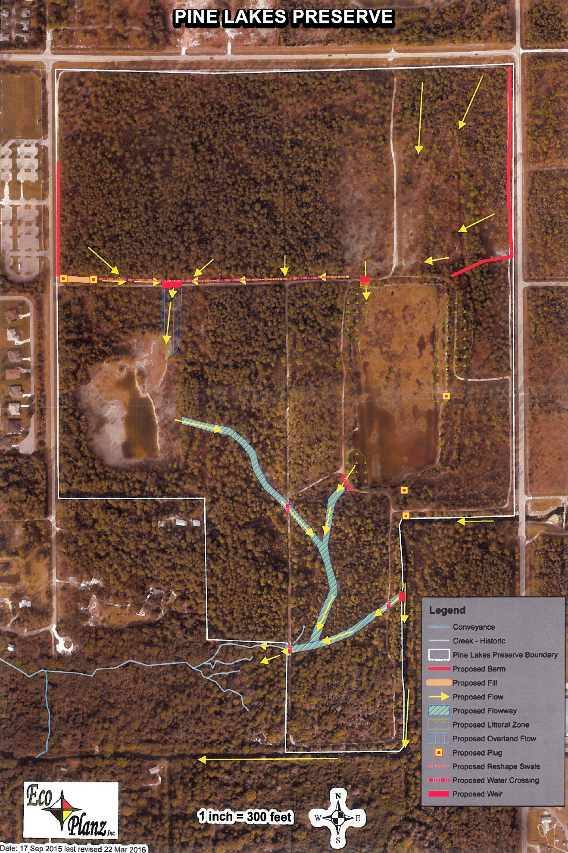

TRANSPORTATION: BONITA BEACH ROAD/US 41 CONGESTION REDUCTION PROJECT (“Quadrant Plan”) REQUEST: $5.25 Million (Local Match: $5.25 Million)
As a significant tourist and beach destination in Lee County, as well as being geographically positioned to be the receiver of all southbound traffic exiting the Town of Fort Myers Beach, significant traffic congestion occurs at Bonita Beach Road and US 41. In order to address this, the City Council has made its top priority reducing this congestion by implementation of its “Quadrant Plan”. This plan would build reliever roads in each of the four quadrants of the intersection, allowing traffic to actually avoid the intersection in favor of these new alternate routes. The request for $5.25 million, matched by the City, would provide a significant improvement to traffic conditions in the area by development of the northern two quadrants, benefitting drivers from all over the region on both the County-owned Bonita Beach Road and the State owned U.S. 41.
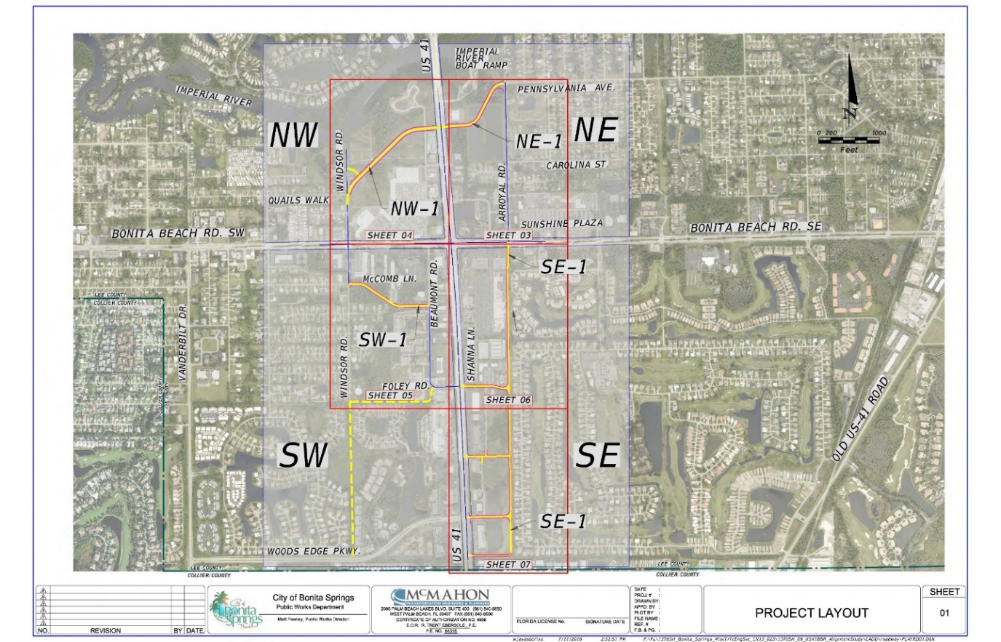
QUADRANT CONCEPT PLAN

Background:
The Quadrant Plan is intended to alleviate traffic congestion at the US 41/BBR corner. Currently, left turn movements are major contributors to the congestion; particularly from southbound US 41 turning east onto BBR, and east bound traffic on BBR turning north onto US 41. The Quadrant Plan is designed to relieve congestion, thus freeing up capacity on the County Road, by opening up road connections around the intersection (e.g. from Windsor Road behind the Publix shopping center, funneling left turning traffic headed north away from intersection.)
In its consideration of the Quadrant Plan, the City is looking to move forward with all due speed. This is a major problem for the community, and requires swift action. The City has already engaged engineering and planning professionals with sterling qualifications. They include John DePalma and his team from McMahon Associates, with decades-long Florida experience; and Ian Lockwood and team of Toole Design, with a national and international pedigree.
Benefits:
Proper funding and implementation of this transportation improvement “Quadrant Plan” will be a benefit to the region’s economic development efforts, public safety and the area’s tourism. Economic Development is adversely impacted when serious traffic backups on Bonita Beach Road west from US 41 delay our visitors from getting to their destinations on time, quickly and efficiently. Public Safety is clearly impacted when emergency vehicles are delayed in traffic congestion. The tourism industry is a large part of our local economy. Many of our visitors and seasonal residents use the Bonita Beach Road/US 41 intersection to travel to many of the area’s attractions. This includes not only the beach goers at Bonita Beach, but also those visiting Fort Myers Beach – since this roadway is the ONLY southern exit off of Fort Myers Beach. Therefore, the Quadrant Plan improvements will benefit not only the City of Bonita Springs, but more importantly, the entire region, as part of an integrated transportation system.
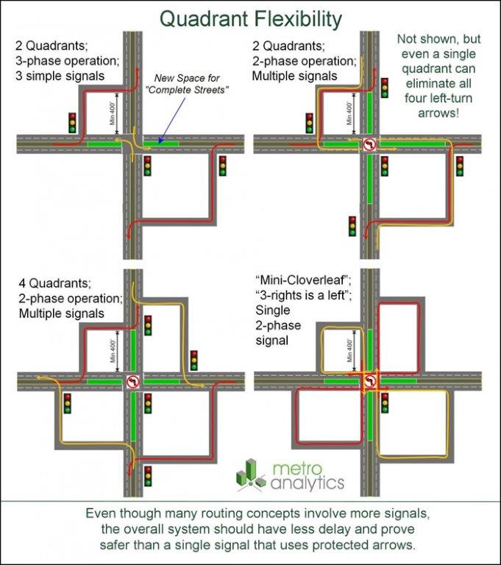

POLICY REQUESTS:
- The City of Bonita Springs supports State funding for projects which would advance enhanced transportation connectivity for pedestrian and bicyclists as well as design and construction of additional “complete” streets.

- The City of Bonita Springs supports efforts to provide State funding for local acquisition of preservation lands in the Density Reduction Groundwater Resource (DR/GR) areas of the City.

- The City of Bonita Springs supports funding for specific City initiatives such as one year of Bio-Reactor monitoring on Felts and improvements to the Pine Lake Preserve.

- The City of Bonita Springs opposes any effort to allow fracking in and around the Southwest Florida area.

- The City of Bonita Springs supports State sustainability initiatives, especially those which would prevent discharges from Lake Okeechobee and which promote clean fresh and salt water bodies. The City also opposes any water quality proposals which would negatively impact our city.

- The City of Bonita Springs supports legislation that would allow pari-mutuel facilities within counties that have passed referendums to provide slot gaming. The City also supports a decoupling of dog racing requirements for pari-mutuel facilities that provide additional gaming.

- The City of Bonita Springs believes in affordable insurance rates for our citizens. Towards that end, the City opposes any action or legislation, at any governmental level, that will have the effect of significantly increasing flood insurance rates.

- The City of Bonita Springs supports State funding of a new visitors center at one of Florida’s most visited State Parks – Lovers Key.
More GENERALLY, the City of Bonita Springs supports increased state funding for education (private, public and charter schools) and supports State sustainability initiatives including possible alternative sources of power and opposes any legislation that would pre-empt Home Rule protection.

Thank you for your consideration!

