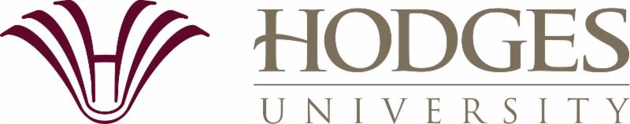

Legislative Session 2018

Hodges University is proud to be southwest Florida’s local, private, non-profit university. Our institution has an important mission as we focus our efforts on deserving students who seek to elevate their lives and to improve their communities.

Hodges has long been friendly to veterans…currently, 11% of our students have served in the armed forces, and again this year, we were again designated a military-friendly school. We are also an acknowledged leader in preparing young women for STEM (science, technology, math and engineering) careers. Hodges is also known for our focus on career preparation, and more than nine out of 10 graduates are either working or going on for additional credentials upon graduation.

Our mission—and success the success of our students—is particularly important given our demographics. Nearly two-thirds of Hodges students are women, and our student body is the most ethnically diverse in our region. Importantly, more than three-quarters of our students are on the lower end of the socio-economic spectrum.

We hope that this information makes clear the crucial nature of state funding for private higher education through programs such as the Florida Resident Access Grant (FRAG).

Data from this year indicate that more than 600 awards were made to Hodges students for a total of nearly $800,000 across all of Florida’s funding mechanisms. Many of our students would likely put their learning on hold—and advancement toward a career, along with service to their employers and communities—were it not for the level of funding in FRAG and other programs.

We appreciate your efforts as legislators to support private non-profit education in Florida, and thank you for service to our great state and its citizens.

