FY19 Legislative Priority:

Teacher Retention through educatOR certification (TREC)
Problem Statement
The School District of Lee County is experiencing rapid gains in student population. The growth in student population leads to the need for additional schools and additional teachers. In spite of a local need for more teachers, the local and national supply of college of education graduates is shrinking. Since 2010, enrollment in teacher preparation programs across the nation has dropped by 42% (Learning Policy Institute). A shrinking supply of traditionally prepared educators leads many districts – including the School District of Lee County – to recruit “career changers” to the classroom. The state of Florida allows career changers the opportunity to teach on a temporary certificate for up to three years. While on a temporary certificate, career changers must pass a series of exams and complete education related coursework. One of the requirements – the General Knowledge Test – must be successfully taken and passed within the first year of teaching. The requirement to take and pass the exam presents a challenge for new teachers who must study and prepare for the exam while learning the important skills of managing a classroom, building relationships with colleagues, and promoting student learning.
Over the past three years, many teachers have been struggled to meet the General Knowledge Test requirement within their first year on the job. A three year trend of non-reappointments due to non-compliance with the General Knowledge Test is presented below. As the chart demonstrates, the number of teachers involuntarily terminated due to non-compliance with this requirement is increasing while the district is experiencing a shortage of teachers. The General Knowledge Test requirement creates a challenge to ensure each classroom is staffed with a qualified, committed educator. See chart below for a three year trend.
Three year trend of terminations due to non-compliance with the General Knowledge Test requirement
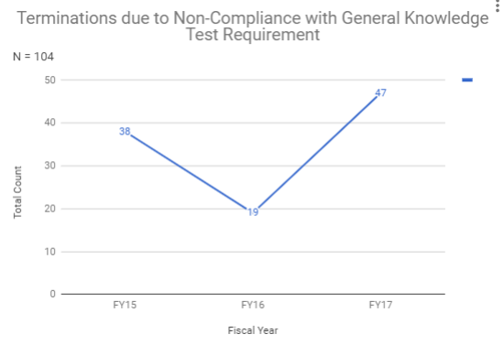

Background Information
The School District of Lee County is not alone in its struggle to retain teachers due to the General Knowledge Test requirement. Throughout the state of Florida, the average pass rate on the General Knowledge Test is 64%, with sub-test scores ranging from a 57% pass rate to 71% pass rate. A chart detailing state pass rates by sub-test is included below.
General Knowledge Test Specifics
Average pass rate of the GK Reading | 61%
Average pass rate of the GK Essay | 71%
Average pass rate of the GK Math | 57%
Average pass rate of the GK English language skills | 64%
Average pass rate overall | 64%

Further data analysis is provided that details the impact of terminations on the workforce due to non-compliance with the General Knowledge Test Requirement. Teacher demographics by ethnicity, gender, and age are presented as well as school type and subject area of instruction.
Teacher Terminations and Demographics (Ethnicity, Gender, & Age)
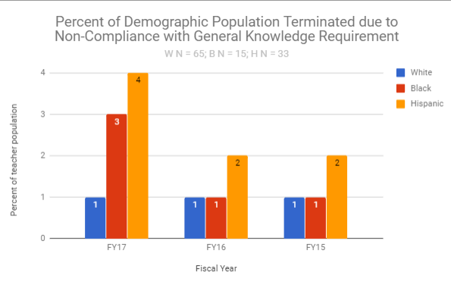
Aside from staffing each classroom with an effective educator, the district desires to employ a teaching force that represents the diverse student population of Lee County. Based on 17/18 enrollment data, 2% of the student population identifies as Asian, 15% of the student population identifies as Black, 39% of the student population identifies as Hispanic, 5% of the student population identifies as multi, and 39% of the student population identifies as White. Teachers who identify themselves as Hispanic experience difficulty meeting the General Knowledge Test requirement at a greater rate than teachers of other demographic groups. See the chart to the right for a percentage of the teacher population for white, black, and Hispanic demographic groups that were terminated due to non-compliance with the General Knowledge Test Requirement over a three year period. For each year, the overall percentage of Hispanic teachers terminated is more than double than that of the White teaching population. See the chart above for a three year trend.

In a profession dominated by females, male teachers are disproportionately negatively impacted by the General Knowledge Test and experience greater rates of turnover due to failure to meet this requirement. See the chart below for a three year trend.
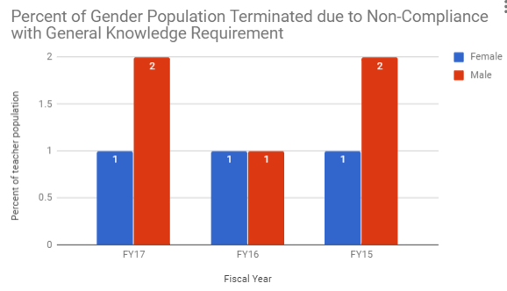
Over a three year period, there does not appear to be a trend of age groups disproportionately affected by the requirement to take and pass the General Knowledge Test within the first year of the job.
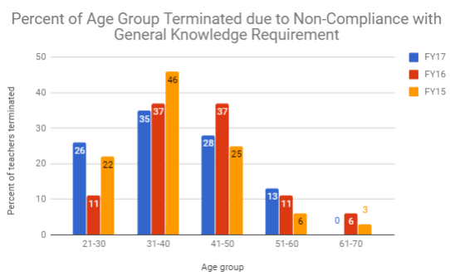
Teacher Terminations and School Type/Subject Areas Taught
Locations classified as Title I that serve a large percentage of students whose families qualify for government assistance seem to be negatively impacted by non-compliance with the general knowledge test requirement. It is important to note that teacher turnover makes it less likely that students will receive instruction from an effective educator. Non-compliance with the general knowledge test requirement is a factor that contributes to teacher turnover in both Title I and non-Title I schools.
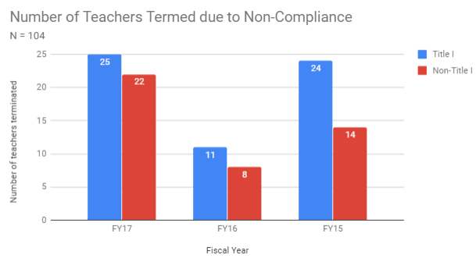
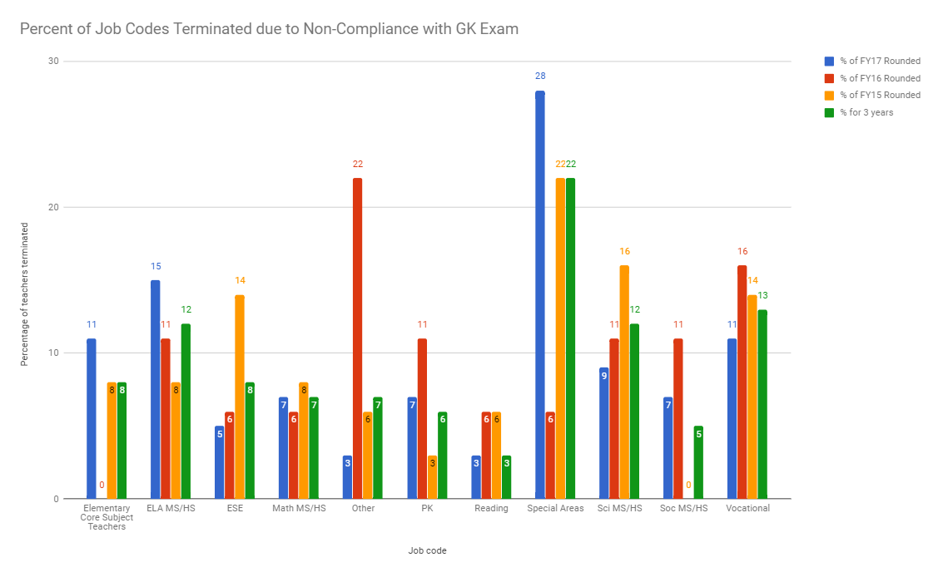
Over a three year period, some subject areas also seem to be negatively impacted by non-compliance with the general knowledge test requirement. Those subject areas include English language arts, special areas, and vocational. A chart detailing the three year trends is included.
Some emerging themes in the data include a higher percentage of Hispanic teachers, male teachers, teachers at Title I schools, and English/Vocational/Special subject areas terminated due to non-compliance with the General Knowledge Test Requirement.
Current Efforts
In the summer of 2017, the School District of Lee County created the Department of Professional Development within Human Resources. The department serves to promote teacher retention through the recruitment and development of pre-service teachers, new teachers, and teacher leaders. In response to a need for assistance preparing and passing the Florida Teacher Certification Exams (FTCE), the department of Professional Development designed and delivered preparation courses in each sub-test of the General Knowledge Test. Trainers studied and took the applicable General Knowledge sub-test in order to develop meaningful training. The department of Professional Development also worked with a local consultant to provide more in-depth training and tutoring opportunities for teachers struggling to pass the test. Finally, the department provided teachers with access to digital resources, such as study guides and e-books to support teachers in independent self-study for the exam. Below is an outline of the department of Professional Development’s efforts towards supporting teacher success with the General Knowledge Test Requirement and current standings.
FY18 General Knowledge Preparation Provided by Professional Development
Number of GK Courses Offered this Year | 44
Number of Attendees Total | 190
Total money in supplemental contracts for trainings for GK Preparation | $5,000
Total money in professional technical services for trainings for GK Test | $3,000
Total money for e-books for self-study | $5,000
FY18 General Knowledge Test Requirements Outstanding
Number of Lee teachers still needing to complete GK Test as of December 2017 | GK Reading | 70
 | GK Language | 67
 | GK Essay | 72
 | GK Math | 72
Number of Lee teachers still needing to complete GK Test as of May 21, 2018 | GK Reading | 38
 | GK Language | 31
 | GK Essay | 44
 | GK Math | 45
Number of Lee teachers still needing to complete GK Test as of June 25, 2018 | GK Reading | 17
 | GK Language | 16
 | GK Essay | 22
 | GK Math | 23

From the Voice of the Teacher
Success story
CN is a Lee County teacher who struggled to meet the requirements of the General Knowledge Exam. He started his career in the specialty food industry, but felt lost after 10 years, so he decided to turn a love for English language arts into a profession. He applied for a temporary certificate in English 6-12 and started teaching 8th graders about real reading and writing. However, the general knowledge test – specifically the math portion - almost drove him from the classroom. CN struggled with math in college, but through the general knowledge test, it returned to haunt him. He almost gave up, but he let go of his pride and personal time to study for the test. After attending all of the trainings offered by the professional development department, CN was able to successfully pass the General Knowledge Math test after multiple failed attempts. He credits, “A support system that did not allow me to fade out of the classroom. The support system was intuitively reactive to my style of learning. I thought about allowing the math to beat me a hundred times, but this specific group of teachers, principals, and professional development staff would not allow me to miss my place in the world. Simply, I had good teachers!” In spite of these challenges, the desire to win for the students keeps CN coming back to the classroom each day. He states, “When you win in the classroom, kids find their place in the world.”
Not yet
Not all first year teachers have experienced CN’s success yet. RM is currently in her first year of teaching and teaches middle school English. She hails from a family of educators, but spent time working as an insurance fraud investigator. One day after driving home from work, she felt a strong calling to teach because she wanted to make a difference in her local community. The “ah ha” moments in the classroom keep her coming back to school each day. She loves to “watch it [the content] click in their minds” and because she has built relationships with her students, they respond to her positively. RM struggles to pass one portion of the general knowledge exam. In fact, she has taken the exam three times. After attending courses developed and taught by professional development team members, her score improved by a few points, but not enough to pass the exam. She is scheduled to re-take the test in June. If she cannot be successful on the third attempt, then she will be forced to lose a job she loves due to this testing requirement.
No longer a part of the profession
After multiple attempts, hundreds of dollars on test registration fees, and many hours of personal time devoted to studying, a middle school math teacher decided to leave the profession. This teacher could no longer put the needs of his family last. He worked two jobs – teaching full time and at night – to support himself and his son with special needs. The demands and costs associated with his many unsuccessful attempts at passing the general knowledge test were too great. Feeling hopeless, he decided quit his position mid-year at a high-needs middle school and work at his second job full-time.

Proposed Solutions
- Change the requirement to satisfy Mastery of General Knowledge [F.S. 1012.56(2)(g)] from within 1 calendar year of the date of employment under the temporary certificate to completion by the end of Temporary Florida Educators Certificate validity period, and remove the continued employment limitations in a school district if Mastery of General Knowledge is not satisfied.

- Allow for additional options to demonstrate Mastery of General Knowledge [F.S. 1012.56(3)];
  - Temporary Certificate holder is rated effective or highly effective based on student learning growth formula (state) within the first year and during the validity period of the Temporary Florida Educators Certificate. or
  - Composite score at or above the 80th percentile on either the SAT or the ACT based on the National Percentile Ranks in effect at the time the test was taken (equivalent to scores acceptable for the Best & Brightest Scholarship). or
  - Completion of 3 semester hours of coursework in each General Knowledge Exam area with a grade of C or higher as documented on an official transcripts from an accredited or approved institution per F.A.C. 6A-4.003.

- Require state to develop a comprehensive preparation course(s) for each section of the General Knowledge Exam, and make the courses available to all individuals employed in a Florida public school district and students enrolled in Florida state-approved teacher preparation programs, at no cost to the individual.

- Provide the General Knowledge Exam in non-English Languages.
Projected Cost Savings and Teachers Retained
The general knowledge test requirement presents many costs to teachers and districts. Due to the turnover of teachers with the General Knowledge Test requirement, the district has lost over $2 million within a three year period. The costs are directly associated with the funds needed to hire and train new employees. On average, the district spends approximately $20,000 to hire and train a new employee. The test also presents a substantial financial burden for first year teachers. The first attempt costs a teacher $130; every attempt afterwards costs the teacher $150. 36% of Florida test-takers will need to re-take the test based on current pass rates, which presents a financial challenge for teachers whose starting salary averages $40,000 in the School District of Lee County. A chart detailing the costs associated with the general knowledge test is outlined below.
Employee and District Costs Associated with the General Knowledge Test
Average cost of test | $130 – first attempt  $150 – second attempt
Average cost to hire and replace a teacher | $20,000
Cost of teacher terminations due to non-compliance with the general knowledge test requirement over three years | FY17 = $940,000
 | FY16 = $380,000
 | FY15 = $760,000

The options presented below detail potential counts of teachers retained and cost savings for two solutions proposed in the previous section. It is important to note that all data might not be complete as many of the individuals are no longer district employees. At this time, data is not available to present potential teachers retained or cost savings for all proposed solutions.
Option 2A: 17 teachers/$340,000
The ultimate goal of classroom instruction is improved student achievement and growth academically. The state of Florida measures teacher effectiveness towards the area of student achievement and growth through the Value-Added Model (VAM). VAM compares the expected growth of students with the actual growth of students. This comparison is then turned into a score for teachers, which is then divided into four performance levels: unsatisfactory, needs improvement, effective, and highly effective. Over a three year period, 17 teachers terminated for non-compliance with the general knowledge test requirement earned a state VAM score of effective or highly effective. The ability to utilize an effective or highly effective state VAM score in place of the general knowledge test requirement would have saved the district approximately $340,000. A chart outlining the counts by effectiveness ratings of available state VAM scores over a three year period is presented below. It is important to note that state VAM data was only available for 30 out of the 104 teachers terminated over a three-year period.
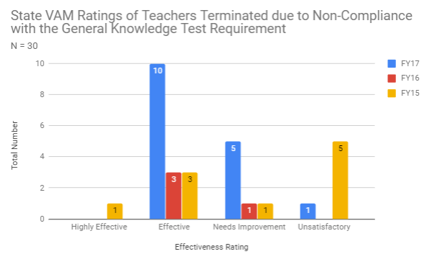
Option 2B: 1 teacher/$20,000
The state of Florida currently provides funding to districts to implement the Best and Brightest Scholarship Program. Under the program, teachers who submit to the district a score report demonstrating their official SAT/ACT score ranking in the 80th percentile of test takers may qualify for the Best and Brightest Scholarship. Award amounts vary as funding is available. In FY18, scholarship amounts ranged from $6,000, $1,200, or $800. This scholarship was designed to attract top ranking college graduates to the teaching profession. Within the three year period, one teacher terminated for non-compliance with the General Knowledge Test requirement met the Best and Brightest Scholarship criteria of earning an ACT or SAT score within the 80th percentile of the testing year.

Implementation Plan
The School District of Lee County is requesting changes to Florida Statutes surrounding the General Knowledge Test Requirement and teacher certificate. The School District of Lee County stands willing to serve as pilot group for this program. Changes in Florida Statutes surrounding this requirement would provide increased opportunities for human resources staff to focus on other priorities, such as the development of teacher skill sets in areas directly impacting instruction and student achievement. Moreover, the money saved from retaining first-year teachers could be utilized to fund additional professional development opportunities for career teachers and administrators. In the end, students will be the greatest benefactors from this plan as a stable and experienced teaching force accelerates student achievement.
Conclusion
The General Knowledge Test requirement presents a challenge for the School District of Lee County to retain a diverse and a qualified teaching staff. An analysis of three years of termination data revealed teachers who identify as Hispanic and/or male were more likely to be terminated due to non-compliance with this requirement. Additionally, teachers teaching in a high-need school or high-need subject area, such as English language arts, were adversely impacted. The School District of Lee County proposes four options to provide flexibility and support to educators struggling to meet this requirement. The options include an extension on the time limit required to take and pass the test, additional options for demonstrating general knowledge, professional development resources to support self-study, and an option to take the test in a language other than English. If the additional options for demonstrating general knowledge were granted, then the district could have retained at least 18 teachers and saved at least $360,000 in costs related to hiring and training new instructional hires.
Appendixes
TBA
References
http://www.fldoe.org/core/fileparse.php/5627/urlt/firsttime-ftce-examinees.pdf
https://learningpolicyinstitute.org/product/coming-crisis-teaching-brief

