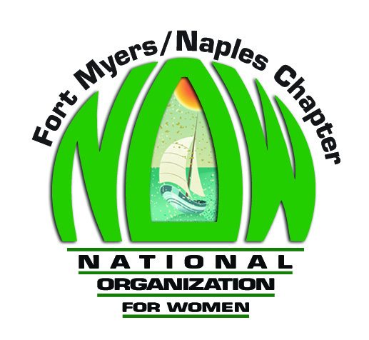

The Fort Myers/Naples chapter of the National Organization for Women encourages you to:
- Support legislation that ensures access to women’s health services, including contraception and safe and legal abortion. Trust women to make the right health choices for their families.
- Continue Medicaid reimbursement funding for basic women’s health care at Planned Parenthood clinics. This is especially important in communities where Planned Parenthood is one of the few or only providers for access to gynecological exams, birth control, cancer screenings, HIV testing, and more.
- Support proposed legislation that would ban assault-style weapons in Florida and large ammunition feeding devices. These weapons of war have no place in our communities. Oppose the open carry everywhere bills.
- Support increases in Florida’s minimum wage that helps the working poor to support their families. $14.52/hr. is needed to support the basic needs of a single person, NOT the current $8.10.
- Support the expansion of Medicaid for eligible Floridians.

Fort Myers/Naples NOW I 239-565-7988 I ftmyersnaplesnow@gmail.com

