Lee County Legislative Delegation
Founded 1886
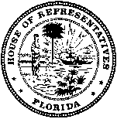
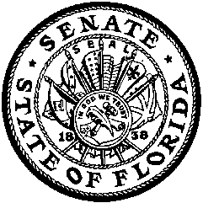
City of Fort Myers | 1885
City of Cape Coral | 1970
City of Sanibel | 1974
Town of Fort Myers Beach | 1995
City of Bonita Springs | 1999
Village of estero | 2015

Senator Lizbeth Benacquisto | Vice Chair |  | Representative Matt Caldwell | Chair
Senator KATHLEEN PASSIDOMO |  |  | Representative Dane Eagle
SENATOR DENISE GRIMSLEY |  |  | Representative Heather Fitzenhagen
 |  |  | Representative Raymond Rodrigues

PRESS RELEASE

FOR IMMEDIATE RELEASE Contact: Charlotte Codie
August 23, 2017 239-694-0161

LEE COUNTY LEGISLATIVE DELEGATION CHAIR ANNOUNCES DATE OF ANNUAL
LEGISLATIVE DELEGATION MEETING

Lehigh Acres, FL – State Representative Matt Caldwell, Chairman of the Lee County Legislative Delegation, today announced the date of the annual Lee County Legislative Delegation Meeting, along with the deadline for filing local bills for consideration during the 2018 Legislative Session.

The Delegation will convene on Wednesday, October 18, 2017 to conduct local business, including a public hearing on local bills (if filed), and other issues for which people may have registered to speak.

The Delegation will conduct its meeting in the Nursing Building (Room AA-177) on the campus of Florida Southwestern State College in Fort Myers (8099 College Parkway, SW, Fort Myers, 33919). The meeting will begin at 9:00AM, and is expected to adjourn no later than 5:00PM, or upon completion of the agenda and public comment.

The deadline for submitting local bills to the Delegation is 5:00pm on Friday, October 6, 2017. All local bills must be accompanied by completed paperwork required by the Florida Legislature via electronic mail to charlotte.codie@myfloridahouse.gov, or mailed to State Representative Matt Caldwell at 15191 Homestead Road, Building A, Lehigh Acres, FL 33971.

The deadline to register to make a general presentation (not related to local bills) to the Delegation is also 5:00pm on Friday, October 6, 2017. Requests for placement on the agenda must be submitted in writing to the mailing address listed above or by electronic mail to charlotte.codie@myfloridahouse.gov Requests made by electronic mail will be acknowledged within two (2) days of receiving the request.

For more information, please contact Charlotte Codie, Legislative Assistant to Representative Caldwell, at 239-694-0161 or at charlotte.codie@myfloridahouse.gov . All meetings of the Lee County Legislative Delegation are open to the public.

# # #

