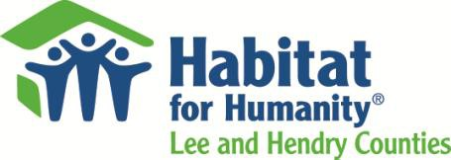

Legislation Delegation Meeting January 19, 2017

The need for affordable housing is tremendous. This year our local affiliate received 13.5 applications for every family we were able to house. You can help in two important ways this session:

- Renew the Community Contribution Tax Credit Program (CCTCP)
  - Just this past year, 25 companies took advantage of the program here in Lee and Hendry Counties, resulting in 30 new homes built for hard working families.
  - CCTCP utilizes a portion of taxes already paid to the state, and returns those directly to the community where they were generated.
  - The program must be renewed this session for it to continue; please renew for 10 years at $25 million/year.

Fully Fund the State Housing Initiative Program (SHIP)

Please use all the housing trust funds solely for housing.
  - Habitat utilizes SHIP funds to help the lowest income families with down payment assistance.
  - The state's interest is secured through a 15 year mortgage.

- In partnership with funding programs like State Housing Initiative Program (SHIP), and the Community Contributions Tax Credit Program (CCTCP), Habitat can revitalize local economies, generate jobs and give Florida’s most vulnerable citizens a lasting hand up, multiplying the positive impact on Florida’s economy and jobs.

- State funding for Habitat for Humanity is a good investment because it is highly leveraged with private donations. Also, Habitat for Humanity homeowners in Florida pay more than $11 million annually in property taxes to the State of Florida.

Questions: Kitty Green, President/CEO, (239) 652-1662, KittyG@Habitat4Humanity.org

1288 North Tamiami Trail, North Fort Myers, FL 33903 • 239.652.0434 (phone) • 239.652.0386 (fax) www.habitat4humanity.org

