Office of Criminal Conflict and Civil Regional Counsel
The Office of Criminal Conflict and Civil Regional Counsel (RCs) was created by the Legislature (Sec. 27.511) in 2007 to provide legal representation to indigent persons and to control rising costs from the private court appointed registry attorneys. Regional Counsel’s main three classes of cases are:
- Criminal conflict cases where the court grants the Public Defender’s motion to withdraw and appoints the RC,
- Dependency and civil cases, and
- Certain statutorily authorized civil commitment proceedings. RC also handles appeals and post-conviction motions.
Since the inception in 2007, Regional Counsel has saved the taxpayers over 30 million dollars each year, which has resulted in a savings of over $330 million dollars.

Districts
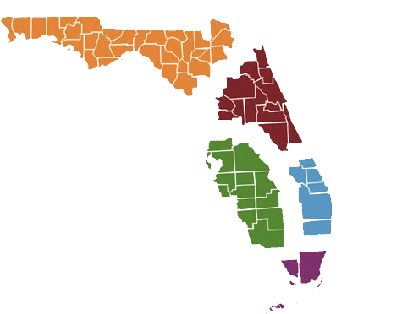
The agency is broken into five main offices, based on the Florida District Courts of Appeal.
Fifth District
Jeffrey Deen
First District
Candice Brower

Second District
Ita Neymotin
Fourth District
Antony Ryan

Third District
Eugene Zenobi

When handled by Regional Counsel, a death penalty trial cost can be approximately one third the cost of a death penalty trial handled by a registry attorney. Regional Counsel is first in line for all dependency cases in the State of Florida. A Dependency case begins when a child is taken away from his parents. The longer a child is in out-of-home care the more taxpayer money is spent. Children want to be with their parents, and studies have shown that children are less likely to be in the criminal system if they are raised at home with their parents, versus in foster care. Regional Counsel attorneys help put families back together by helping parents make better choices, and save taxpayers millions of dollars.

