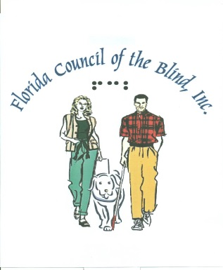
FLORIDA COUNCIL OF THE BLIND INC.
1531 DEMPSEY MAYO ROAD
TALLAHASSEE, FL 32308
(850) 422-7752
(800) 267-4448
www.fcb.org

The Florida White Cane Law

White cane laws have protected the rights of pedestrians who are blind or have mobility impairments for many years. However, in Florida as in other states, many drivers have no idea of what the White Cane Law is or what it says. In addition, there is virtually no effort being made to maintain records of incidents involving people with disabilities. People with disabilities have the right to assume that laws that are on the books are being enforced and are understood. However, this is simply not the case. Florida's White Cane Law is actually found in two places. S. 316.1301 covers pedestrians who are blind. S. 316.1303 cover pedestrians who have mobility impairments.

What does the Florida Legislature need to do to insure that the Florida White Cane Law truly meets the needs and honors the civil rights of the people for which it was enacted?

First, there must be a requirement that incidents involving people with disabilities be reported to a state agency and that records be kept on all crimes involving people with disabilities so that it will be possible to know just how often such people are involved in incidents. Second, there must be a requirement that everyone seeking a driver's license answer a question relating to the White Cane Law. Third, driver's education programs including those taught in high school must include information about the white cane law. Fourth, training for police must now include education on the rights of pedestrians who are disabled.

Remember that disability can touch you, your family and/or close friends in an instant as a result of a birth defect, disease, accident or the aging process. We urge you to begin discussing the importance of the Florida White Cane Law with law enforcement officers, your representatives in the Florida Legislature, representatives of the media and anyone and everyone whom you believe can assist with strengthening this crucially important civil rights law., its egregious lack of enforcement and the necessity of implementing the requirements outlined above.

The enactment of the modifications in the Florida White Cane Law addressed in this document will create a living, meaningful law that does what it is designed to do, to protect people with disabilities as they exercise their civil right to access the streets and highways of the State of Florida. As a result, people who seek driver's licenses will be required to know about the law and we will be able to know just how often it is broken. When police know about the law, they will be more likely to enforce it. People who are blind cannot see the people who are breaking the law. It is up to the police to enforce the law.

Will you help us to insure that the Florida White Cane Law becomes a law that truly honors the intent of its enactment?

Submitted by Michael D. Ulrich
4642 Coronado Pkwy. A-101
Cape Coral, Fl. 33904
Home phone: 239-540-7431
Cell phone: 239-565-5845
Email: mulrich@centurylink.net

